# Exercise 2

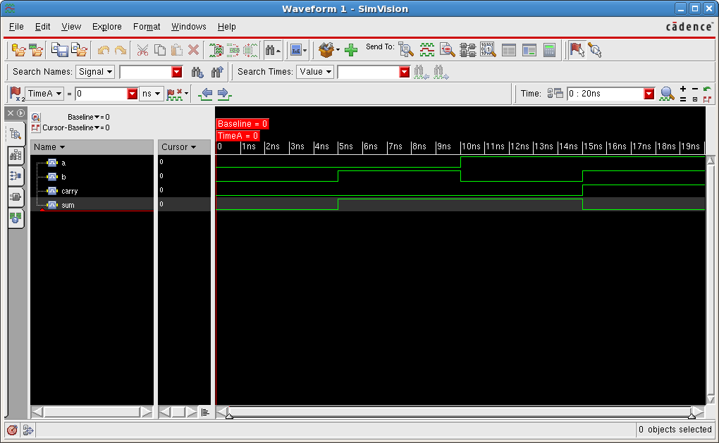

The waveform above shows all possible input combinations (a, b, carry) and the correct output (sum).

# Exercise 5

Demonstrating part of the sweep that covers all input combinations.

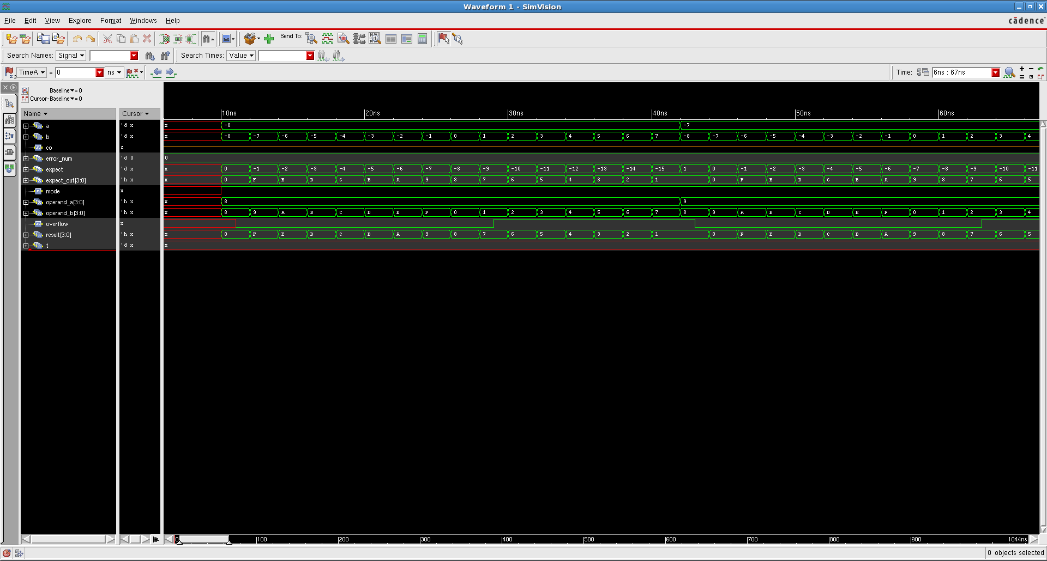

6 - 7: (demonstrating negative result)

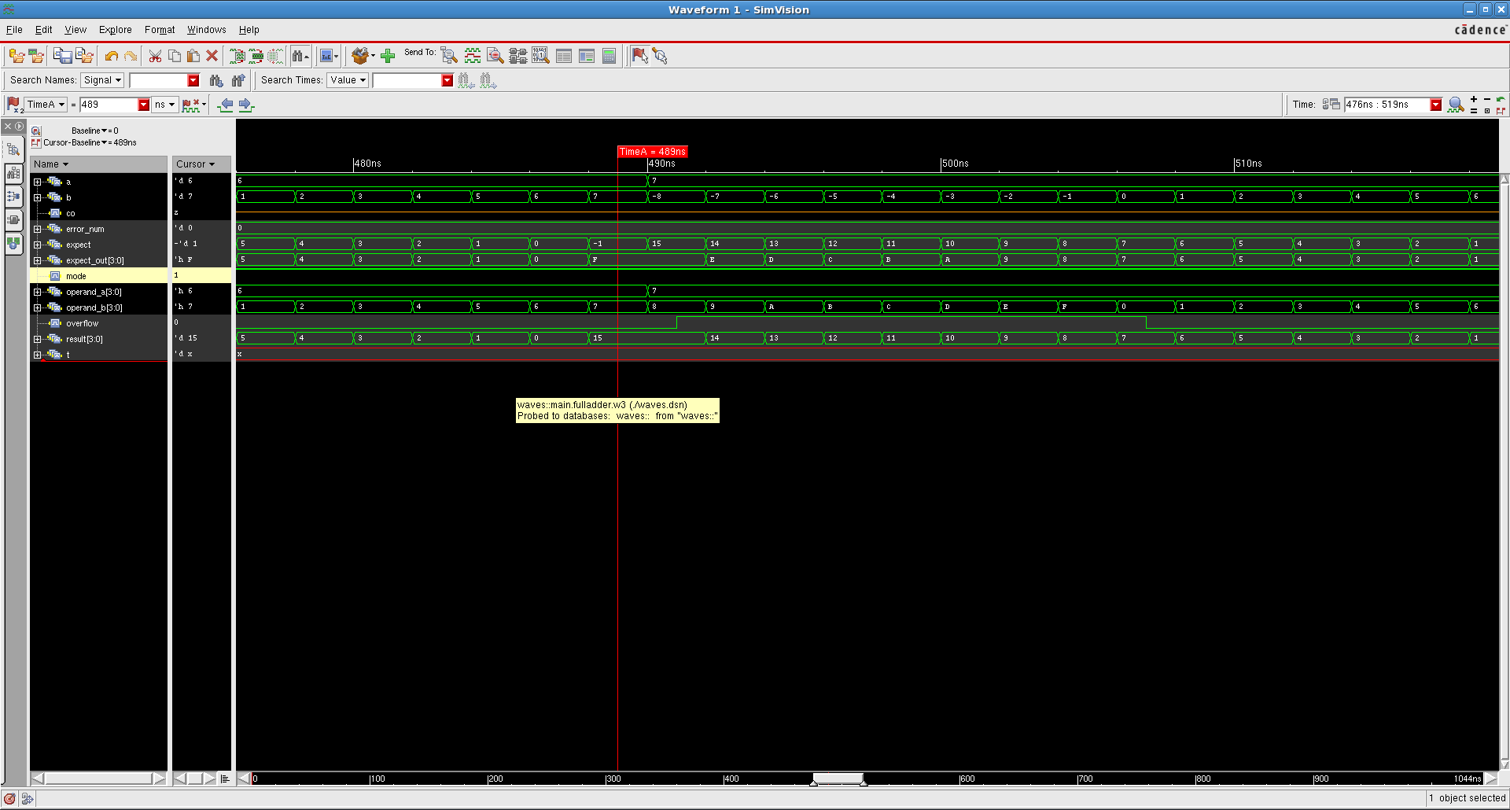

-8 - -7: (demonstrating subtraction of negative from negative)

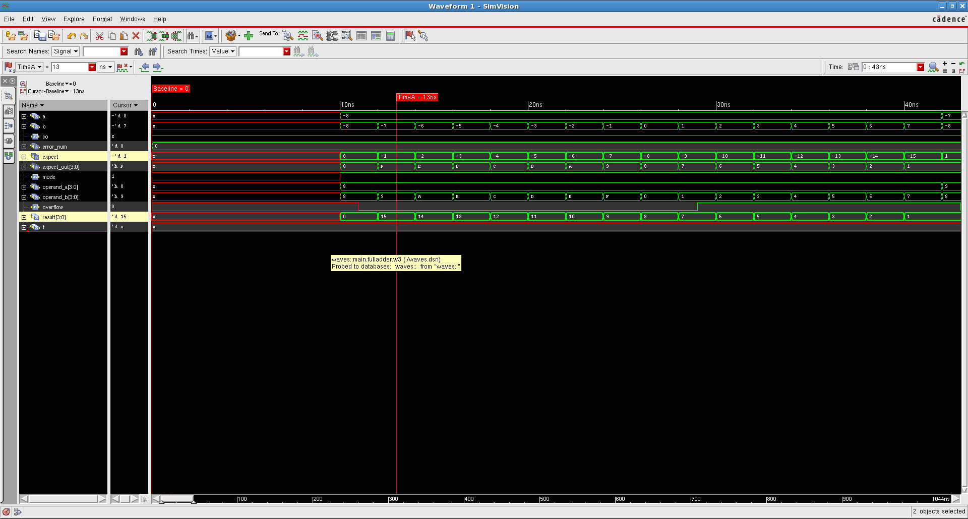

-8 + -7: (demonstrating underflow in addition, result is 1 instead of -15)

